Aim: Create Sociograms for different network types.
#Unipartite Network (One-Mode)
#Step 1: import Libraries

import networkx as nx
import matplotlib.pyplot as plt

#Step 2: Create a Unipartite Graph
G_uni=nx.Graph()
G_uni.add_nodes_from(["Alice","Bob","Cathy","Dan","Eva"])

#Add Nodes
G_uni.add_edges_from([
("Alice","Bob"),
("Alice","Cathy"),
("Bob","Dan"),
("Cathy","Eva"),
("Dan","Eva")
])

plt.figure(figsize=(6,6))
nx.draw(G_uni, with_labels=True, node_color='lightblue',edge_color='gray',node_size=2000)
plt.title('Unipartite Sociogram')
plt.show()

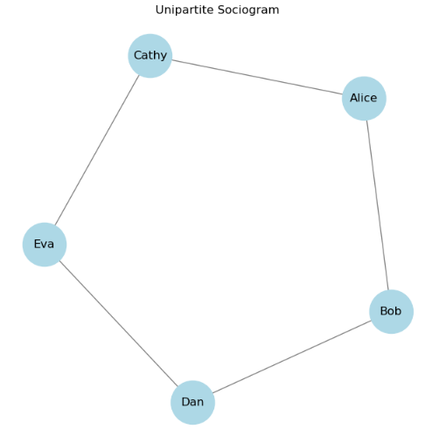

#Bipartite Network(Two-Mode)

#Step 3: Import Additional Tools
from networkx.algorithms import bipartite

B = nx.Graph()
people = ["Anna", "Ben", "Clara"]
events = ["Yoga", "Book Club", "Painting"]

B.add_nodes_from(people, bipartite=0)
B.add_nodes_from(events, bipartite=1)
B.add_edges_from([("Anna","Yoga"),("Ben","Yoga"),("Ben","Book Club"),("Clara","Painting"),("Clara","Book Club")])

pos = nx.bipartite_layout(B, people)

plt.figure(figsize=(8,6))
nx.draw(B, pos, with_labels=True, node_size=2000,
node_color=["lightgreen" if n in people else "lightcoral" for n in B.nodes()],
edge_color="gray")

plt.title("Bipartite Sociogram")
plt.show()plt.show()

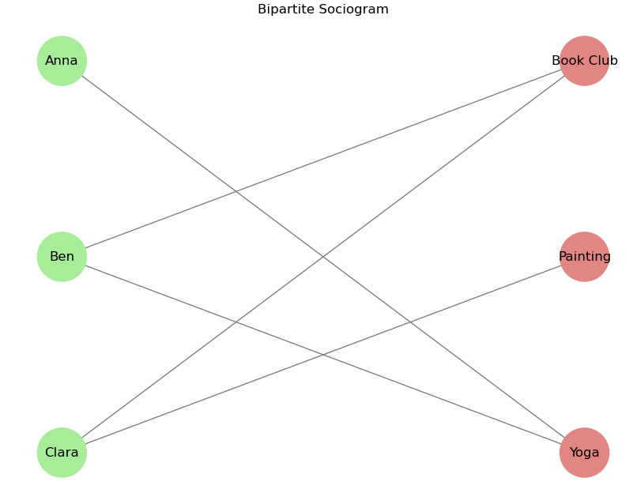

Case Study: Political Committees Network – Visualize connections between members in political committees (person-by-person and committee-by-committee sociograms

# Step 1: Import Libraries
import networkx as nx
import matplotlib.pyplot as plt

# Step 2: Create Person-by-Person Network
G = nx.Graph()

G.add_edges_from([
("Alice","Bob"),
("Alice","Cathy"),
("Bob","David"),
("Cathy","Eva"),
("David","Eva"),
("Bob","Eva")
])

plt.figure(figsize=(6,6))
nx.draw(G, with_labels=True, node_size=2000,
node_color="lightblue", edge_color="gray")

plt.title("Person-by-Person Sociogram")
plt.show()

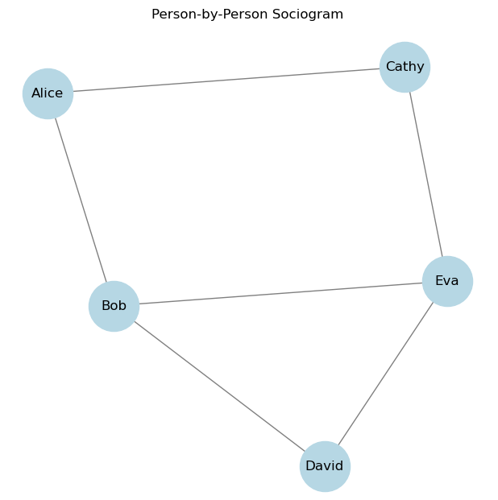

# Step 3: Create Committee-by-Committee Network
C = nx.Graph()

C.add_edges_from([
("Finance","Health"),
("Finance","Education"),
("Health","Environment"),
("Education","Environment"),
("Finance","Environment")
])

plt.figure(figsize=(6,6))
nx.draw(C, with_labels=True, node_size=2200,
node_color="lightgreen", edge_color="gray")

plt.title("Committee-by-Committee Sociogram")
plt.show()

